SnSSe Thermoelectric Prediction and Doping Screen
Detailed report for Sn S Se compositions and Ag-doped screening
Prepared from the supplied papers, source datasets, project code, model outputs and external verification records. Measured values, formula checks and model extrapolations are labelled separately.

Executive summary
The SnSSe project searched the supplied dataset directory recursively, extracted relevant Sn-S-Se and Co3InSnSSe curves, combined them with the curated ESTM table, built composition descriptors and evaluated multiple regressors under composition-grouped validation. The final table contains 5,255 measured rows from 880 composition groups. ExtraTrees is strongest (grouped-CV R2 0.698, MAE 0.109, RMSE 0.193). No newly generated doped candidate reached predicted ZT >= 1 throughout 300-600 K. This is a model-screening result, not evidence that no material can reach 1.
Item | Result | Interpretation
Combined data | 5,255 rows; 880 groups | 4,830 ESTM + 425 Starrydata
Best grouped CV | ExtraTrees R2 0.698, MAE 0.109, RMSE 0.193 | Composition-grouped
Held-out groups | R2 0.745, MAE 0.097, RMSE 0.166 | Separate check
Highest new candidate max | About 0.819 | None >= 1 across 300-600 K
Requested target | Sn0.99Ag0.01S0.94Se0.06 | Exact measured PF/kappa not found
Result type | Model extrapolation | Needs measurement or DFT

Scope and source papers
The reference paper is Li et al., Journal of Alloys and Compounds 1037 (2025) 182164, DOI 10.1016/j.jallcom.2025.182164. It reports 1,093 samples, 184 features, variance filtering, XGBoost recursive elimination, Monte Carlo subset testing, Pearson pruning, six regressors, an 80:20 split and 10-fold CV. It models PF and thermal conductivity, computes ZT = PF x T / TC, then uses SHAP and DFT stability checks for proposed SnSe compositions. The present workflow adopts these principles but uses grouped validation because the supplied curves contain repeated temperatures per composition.
The reference paper's SnSe0.25Te0.75 example reports ML and DFT values near zT 1.6 at 900 K after mechanical, dynamical and thermal stability checks. Those checks were not performed here and must not be claimed for the SnSSe candidates.

Dataset scan and parsing
The Datasets directory was scanned recursively. ESTM contributes 4,830 rows and extracted Starrydata contributes 425 rows for Sn-S-Se and Co3InSnSSe. No standalone pure SnSSe composition cell was found. The literal SnSSe string occurs inside Co3InSnSSe, a different quaternary material; it is retained with its provenance and is not labelled pure SnSSe.
Family | Finding | Treatment
ESTM clean table | 4,830 rows | Measured training table
Starrydata Sn-S-Se | 425 rows | Merged with source and DOI
SnSxSe1-x | Includes Se fractions 0.03, 0.06, 0.09, 0.12, 0.20, 0.30, 0.40, 0.50 and 0.80 | Measured references
Co3InSnSSe | Literal SnSSe text but quaternary | Separate group
Exact Ag target | No measured local row | PF/kappa predicted separately

Feature engineering and feature selection
Formula strings were parsed into normalized elemental fractions. Descriptors include temperature, number of elements, mixing entropy, element fractions, weighted/minimum/maximum/range/standard-deviation statistics for atomic mass, atomic number, electronegativity and radius, formula mass, Sn-Se imbalance and S/Se ratio. This is a transparent lightweight analogue of Matminer, not a claim to reproduce Matminer values. Measured PF, kappa and zT are excluded from the ZT descriptor matrix. Ridge uses in-fold SelectKBest; trees use the descriptor set directly. ExtraTrees permutation importance ranks temperature 0.891, Te 0.112, Sb 0.054, Ge 0.054 and Ag 0.053, followed by radius, mass, atomic number and mixing entropy descriptors.

Models and cross-validation
Models are Ridge with in-fold selection, Random Forest, ExtraTrees and Gradient Boosting. GroupKFold by composition is primary; a separate held-out composition-group split is also reported. This is stricter than a random 80:20 row split because neighboring temperature rows from one curve are dependent.
Model | Split | R2 | MAE | RMSE
Ridge_select | grouped CV | 0.259 | 0.231 | 0.302
RandomForest | grouped CV | 0.644 | 0.117 | 0.209
ExtraTrees | grouped CV | 0.698 | 0.109 | 0.193
GradientBoosting | grouped CV | 0.474 | 0.181 | 0.254
Ridge_select | held-out groups | 0.297 | 0.213 | 0.276
RandomForest | held-out groups | 0.719 | 0.103 | 0.174
ExtraTrees | held-out groups | 0.745 | 0.097 | 0.166
GradientBoosting | held-out groups | 0.485 | 0.173 | 0.236

Errors found, root causes and fixes
- Pure SnSSe was separated from Co3InSnSSe; the literal string alone is not enough to identify a binary composition.
- Ag on the Sn site is normalized as Sn1-xAgxS0.94Se0.06, so x = 0.03 is Sn0.97Ag0.03S0.94Se0.06; Sn0.99Ag0.03 is not normalized for this substitution.
- The exact Sn0.99Ag0.01S0.94Se0.06 measured PF/kappa row was not found, so its outputs are labelled model extrapolations.
- Random row leakage was removed with grouped CV and held-out groups.
- ZT is recomputed from PF, T and kappa only when units are compatible; direct ZT and PF/kappa outputs are shown separately.
- All generated candidates are marked extrapolation_flag = True; no DFT, phonon, phase-stability or experimental checks are implied.

Measured references and candidate screen
Measured references include SnS0.88Se0.12 (about 1.02 maximum), SnS0.91Se0.09 (about 1.64), SnS0.94Se0.06 (about 1.25) and SnS0.97Se0.03 (about 1.13). These show that zT >= 1 exists in the measured collection. The newly generated doped screen did not produce a candidate >= 1 across 300-600 K; the highest direct candidate maximum was about 0.819.
Candidate | Min ZT | Mean ZT | Max ZT | All T >= 1? | Status
Sn0.99Ag0.01S0.94Se0.06 | 0.524 | 0.686 | 0.800 | No | Model extrapolation
Sn1S0.94Se0.06 | 0.524 | 0.697 | 0.819 | No | Baseline model
Sn0.99Sb0.01S0.94Se0.06 | 0.514 | 0.680 | 0.798 | No | Model extrapolation
Sn0.99Cu0.01S0.94Se0.06 | 0.510 | 0.677 | 0.807 | No | Model extrapolation
Sn0.97Ag0.03S0.94Se0.06 | 0.508 | 0.664 | 0.770 | No | Model extrapolation
Measured SnS0.91Se0.09 | - | - | about 1.64 | Observed > 1 | Measured source

Requested target Sn0.99Ag0.01S0.94Se0.06
The nearest measured baseline is SnS0.94Se0.06: PF = 4.211 mW m-1 K-2 and zT = 0.495 at 300 K, PF = 3.160 and zT = 0.738 at 423 K, and PF = 1.916 and zT = 0.826 at 573 K. Separate ExtraTrees models for PF and kappa were evaluated for the requested Ag-doped formula and combined with zT = PF T / kappa. The following values are model estimates, not exact measurements.
T (K) | PF (mW/mK2) | kappa (W/mK) | Formula ZT | Direct model ZT | Status
300 | 3.742 | 2.344 | 0.479 | 0.524 | Model extrapolation
350 | 3.437 | 2.088 | 0.576 | 0.576 | Model extrapolation
400 | 3.117 | 1.818 | 0.686 | 0.661 | Model extrapolation
450 | 2.779 | 1.630 | 0.767 | 0.703 | Model extrapolation
500 | 2.413 | 1.450 | 0.832 | 0.736 | Model extrapolation
550 | 2.072 | 1.310 | 0.870 | 0.798 | Model extrapolation
573 | 1.909 | 1.263 | 0.866 | - | Model extrapolation
600 | 1.805 | 1.185 | 0.914 | 0.800 | Model extrapolation

PF decreases with temperature while predicted kappa also decreases. Formula-based ZT rises toward 550-600 K, but 600 K is an edge-of-range extrapolation. Direct ZT and PF/kappa-derived ZT differ because they are separate fits; the disagreement is an uncertainty signal.

Where the models were right and where they failed
The models captured broad composition and temperature structure, obtained grouped-CV R2 near 0.70 for ExtraTrees, and ranked temperature as the dominant descriptor. They failed as a discovery oracle for new >=1 candidates because candidate descriptors sit outside measured trajectories, sources use different protocols, and the kappa branch is weak (grouped-CV R2 about 0.449). High-temperature errors are amplified by nonlinear carrier activation, bipolar conduction, transitions and thermal-boundary effects. A good parity plot does not guarantee a reliable 600 K endpoint.

Training and testing graphs
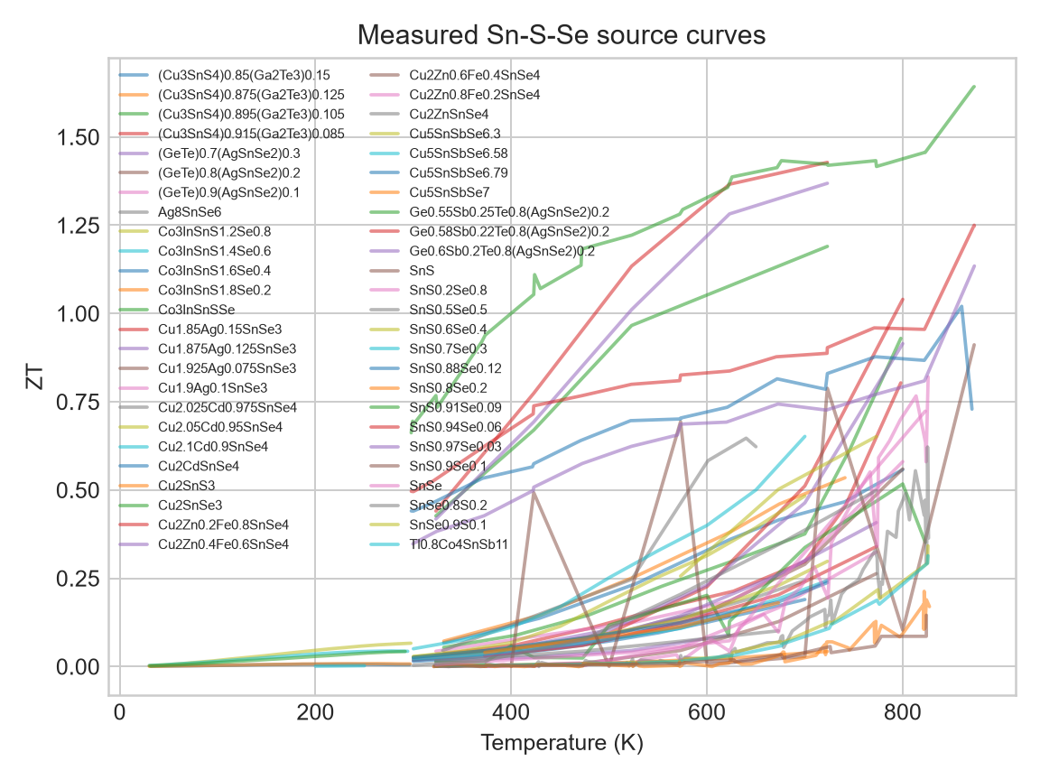
Measured Sn-S-Se source curves, including high-ZT references.
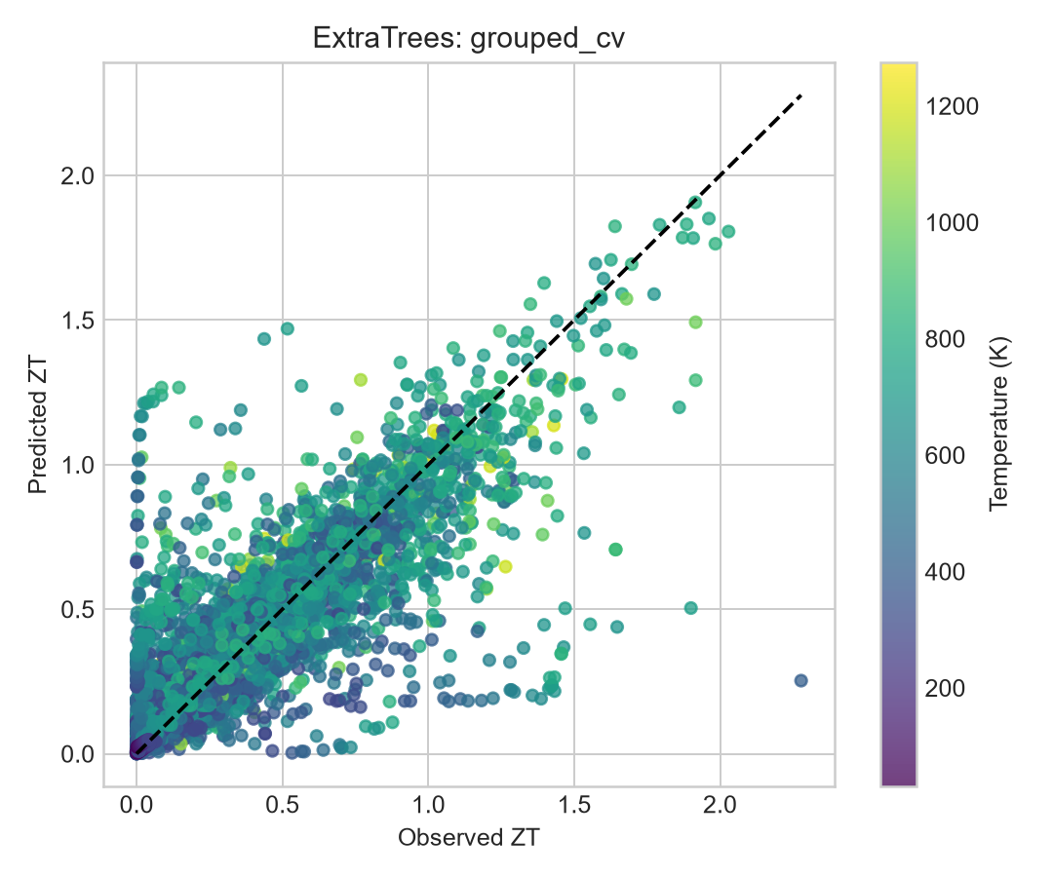
ExtraTrees grouped-CV parity.
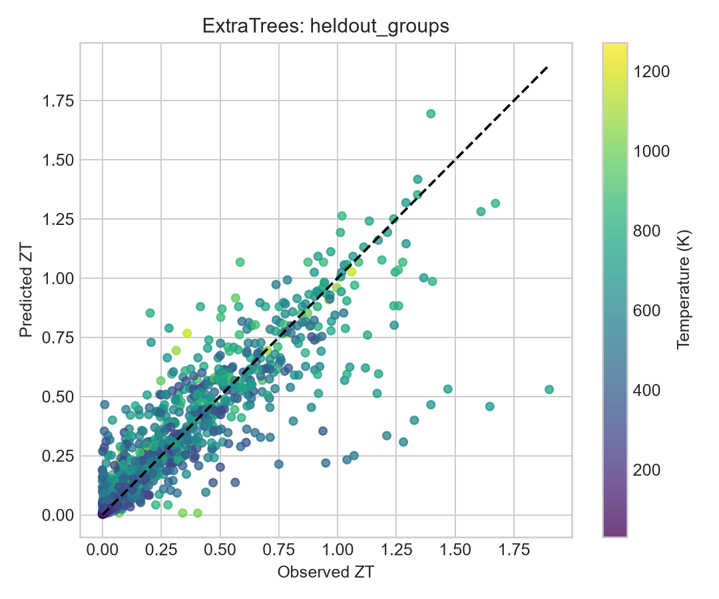
ExtraTrees held-out composition-group parity.
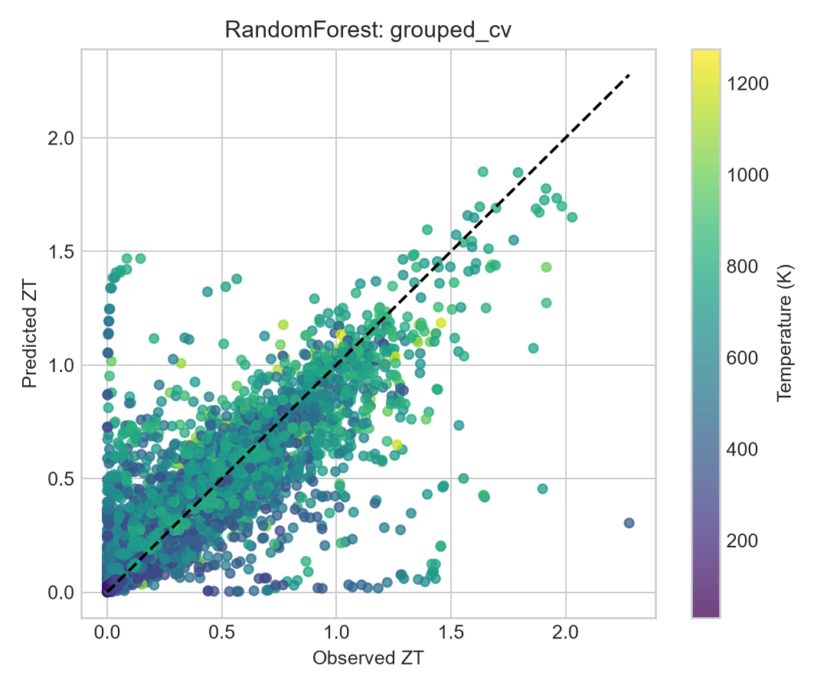
Random Forest grouped-CV parity.
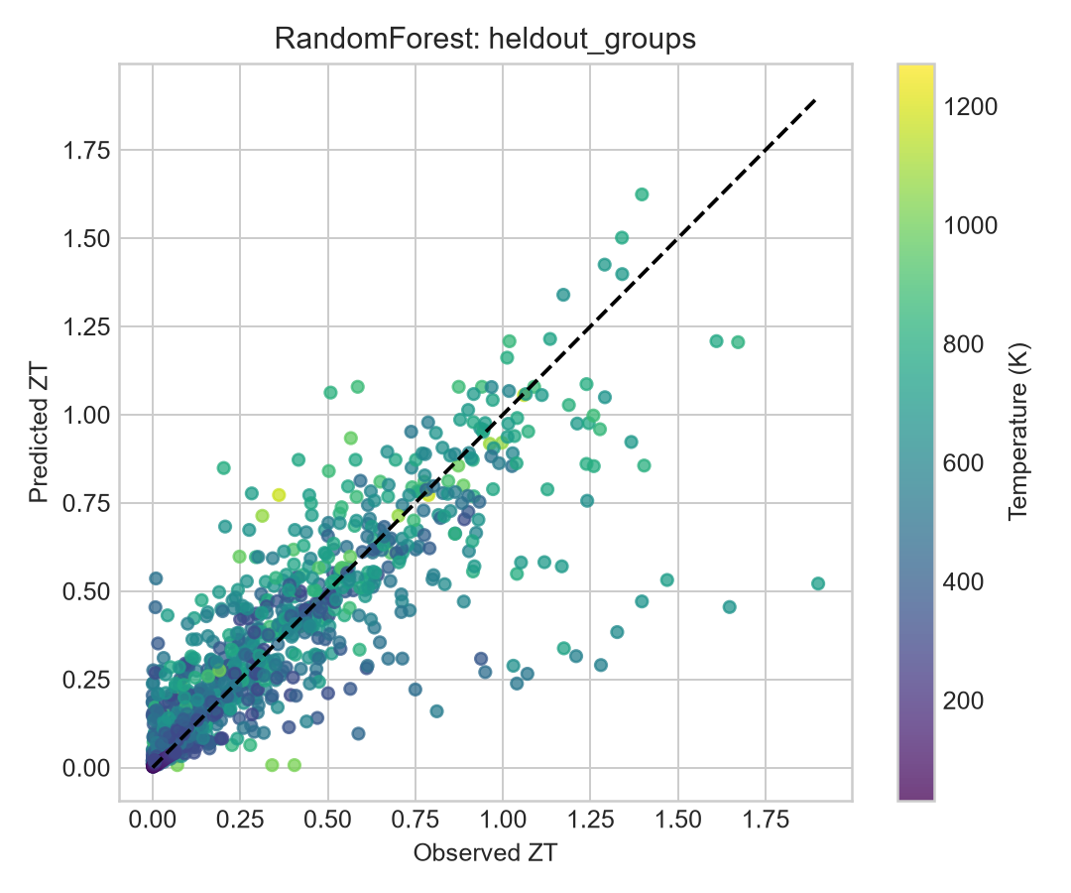
Random Forest held-out-group parity.
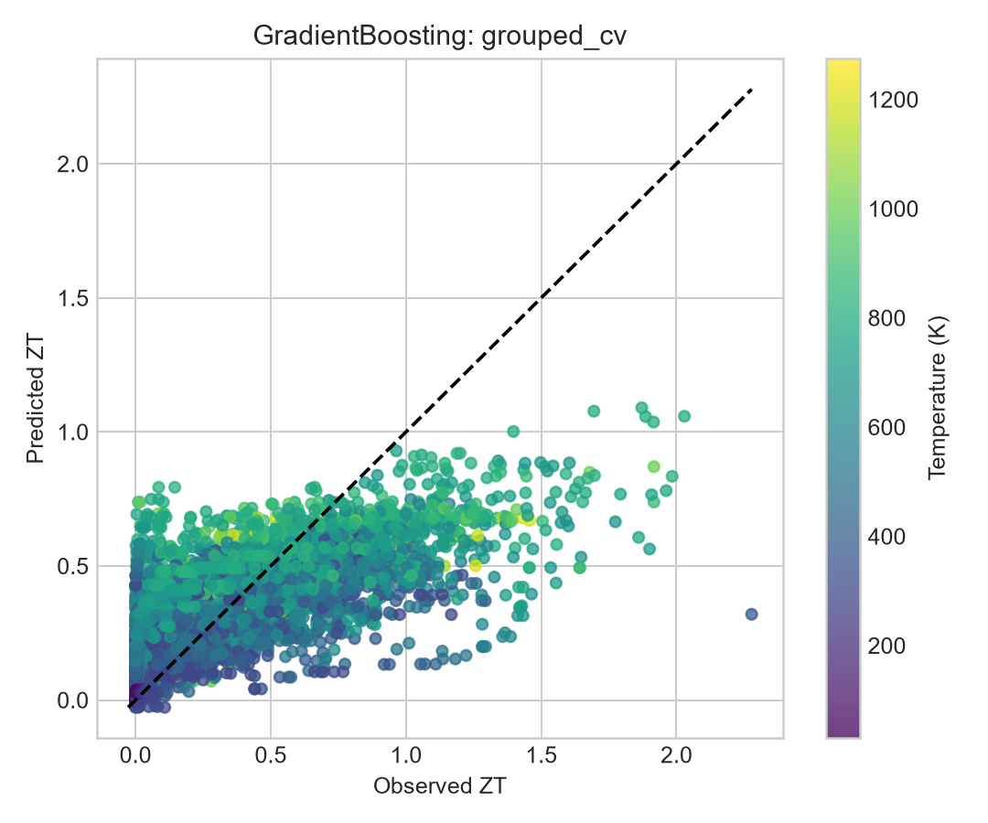
Gradient Boosting grouped-CV parity.
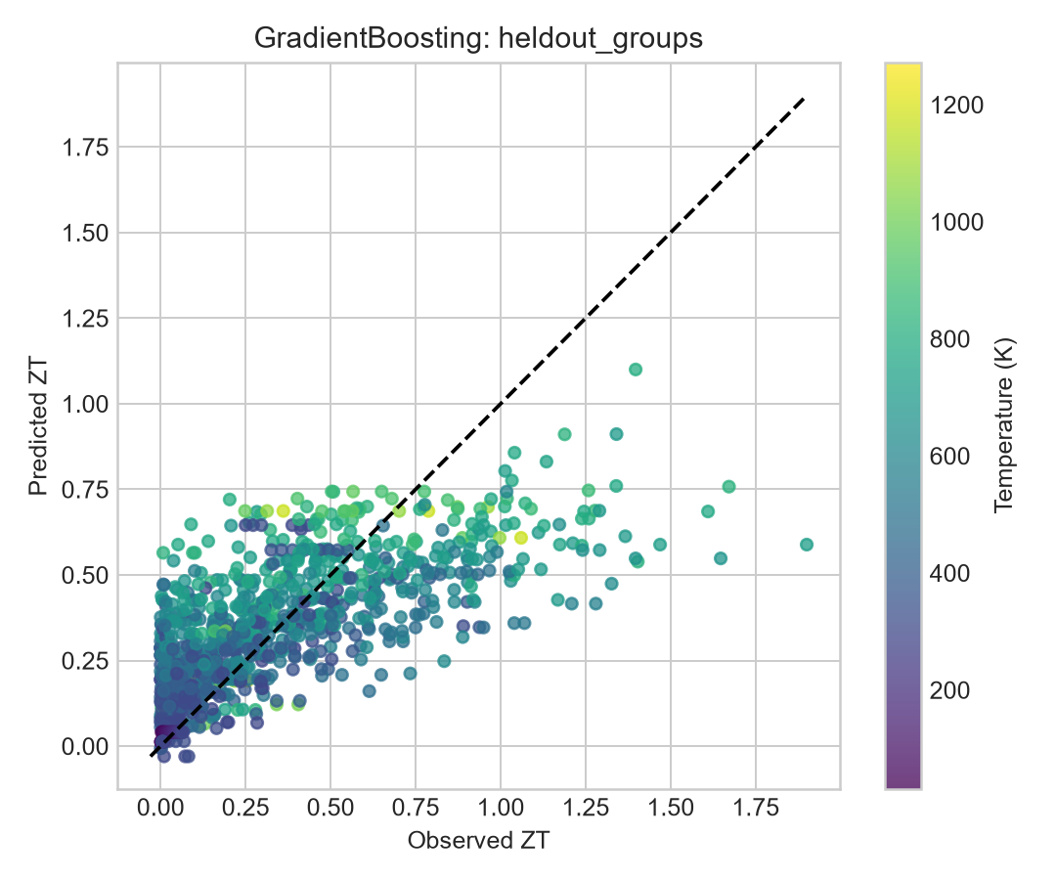
Gradient Boosting held-out-group parity.
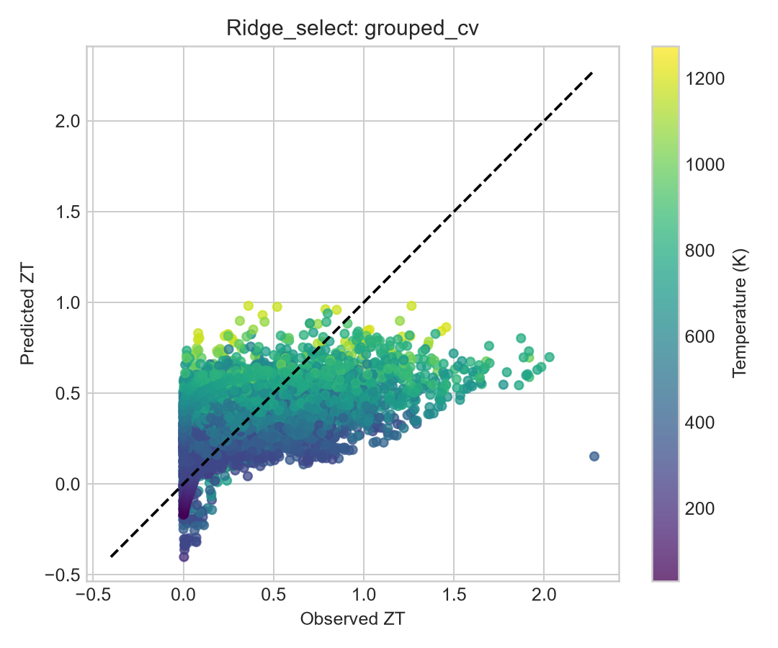
Ridge grouped-CV parity.
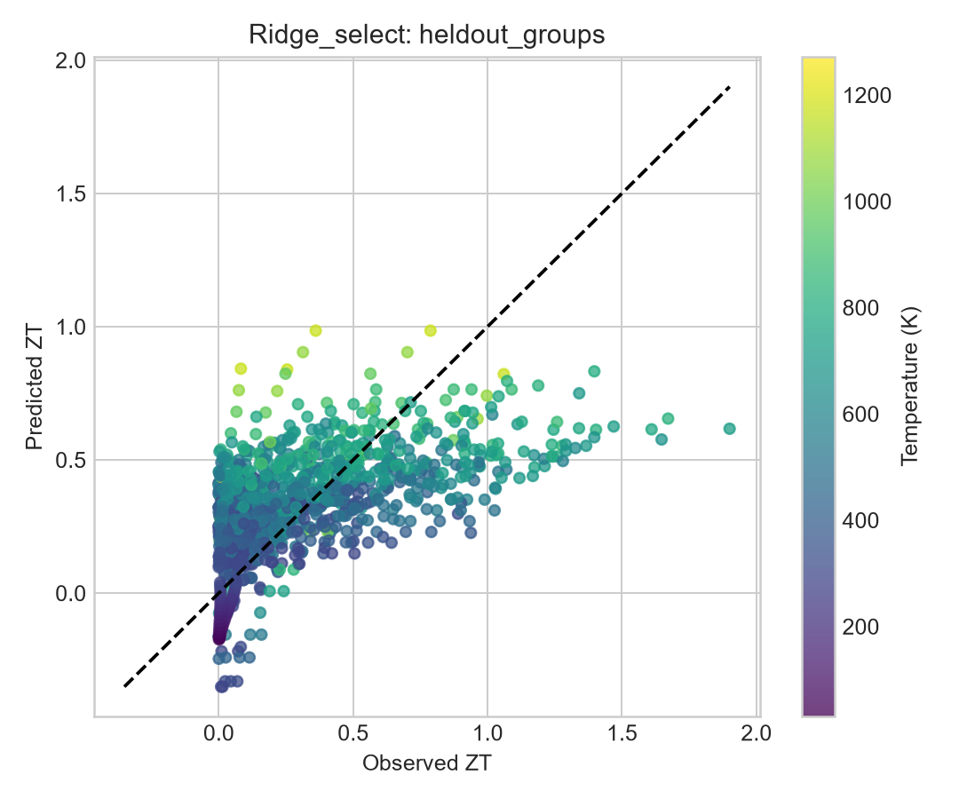
Ridge held-out-group parity.
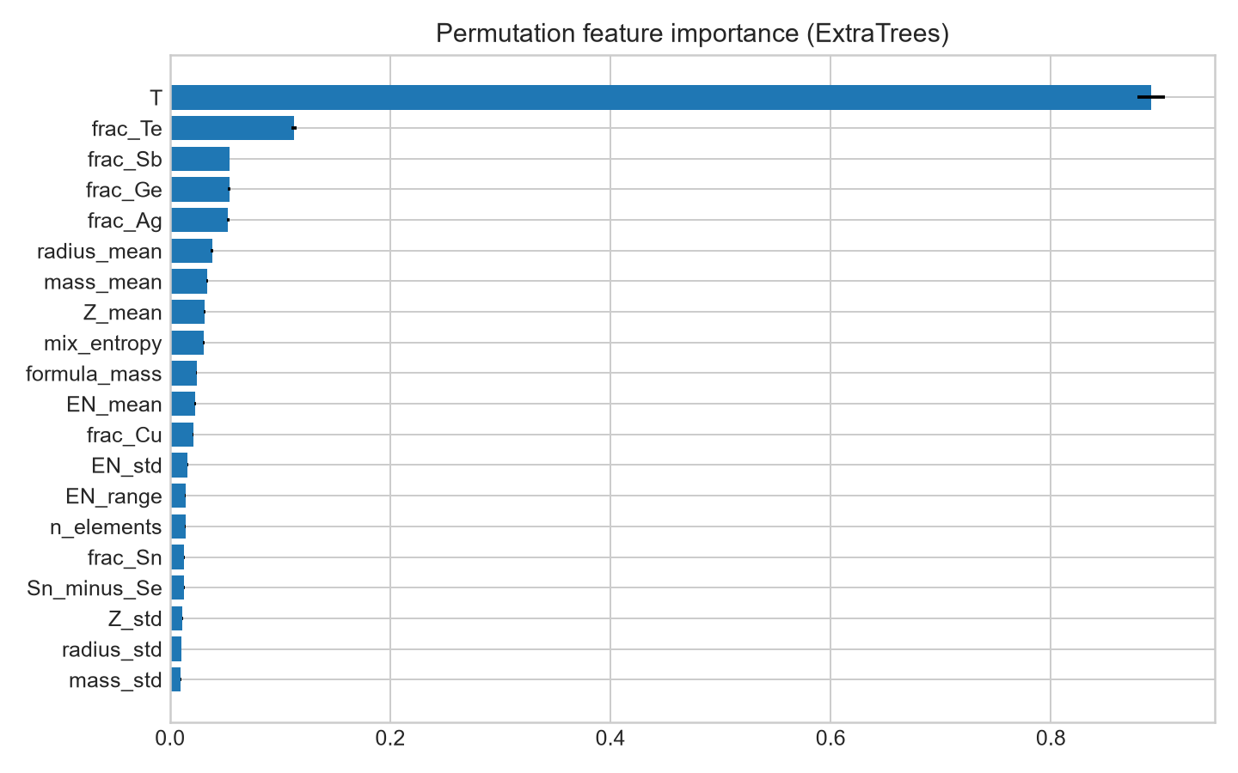
Permutation feature importance for ExtraTrees.
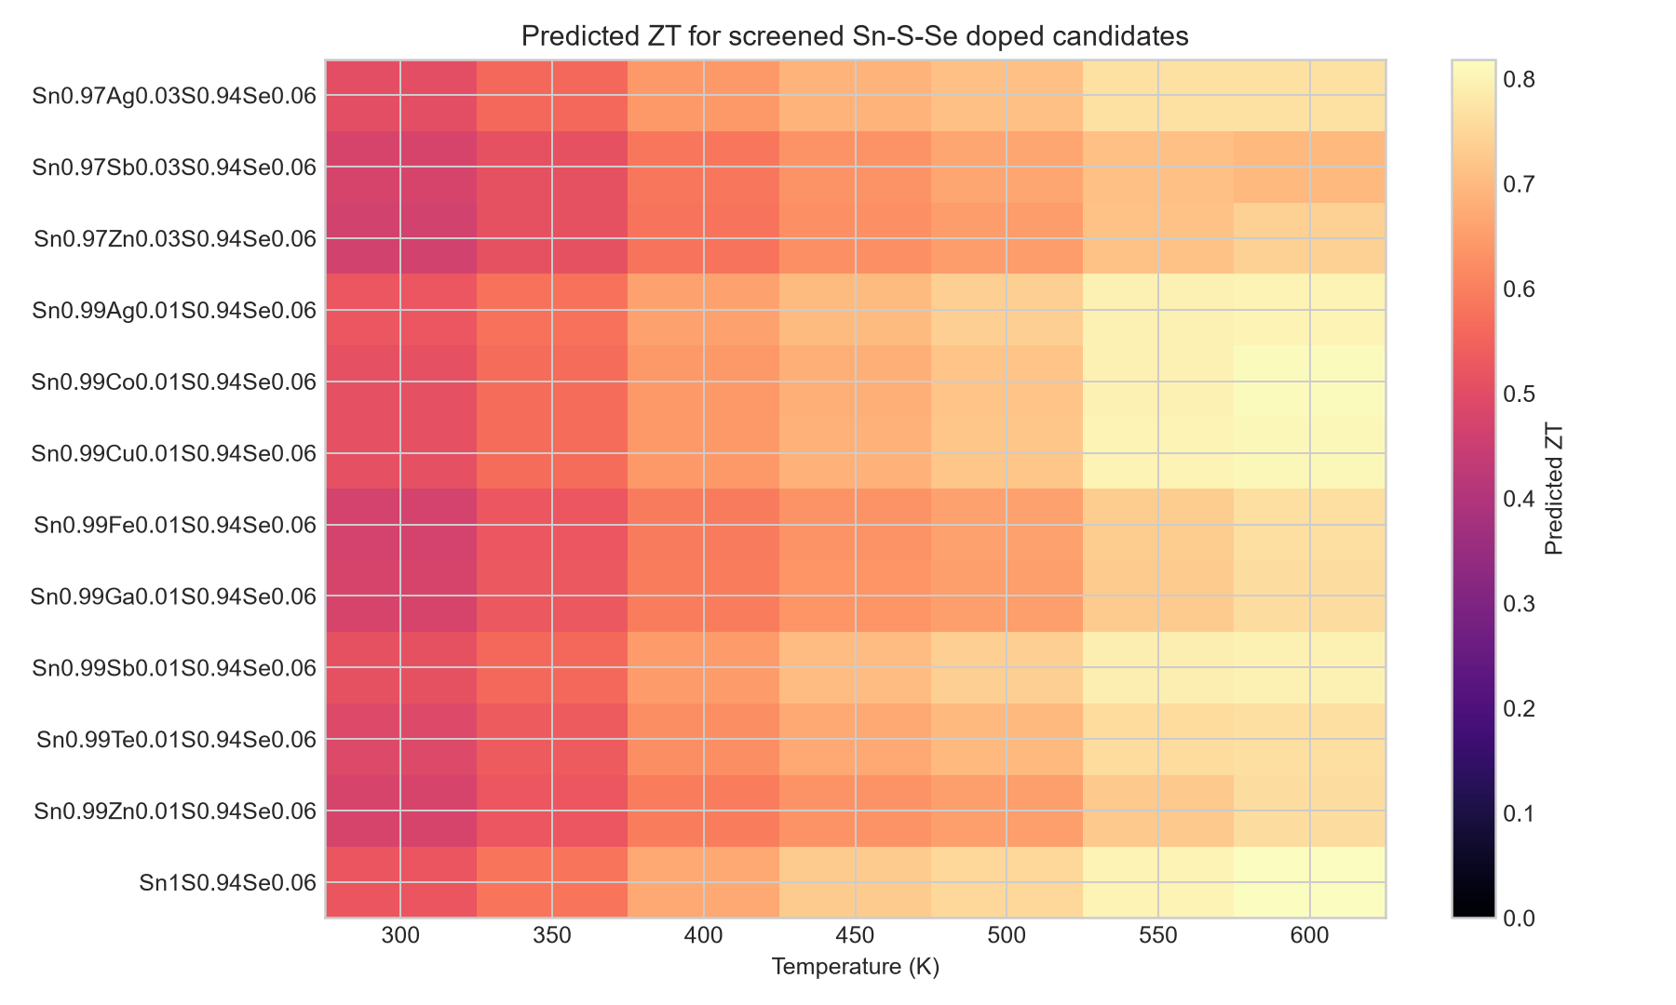
Predicted candidate ZT heatmap, 300-600 K.
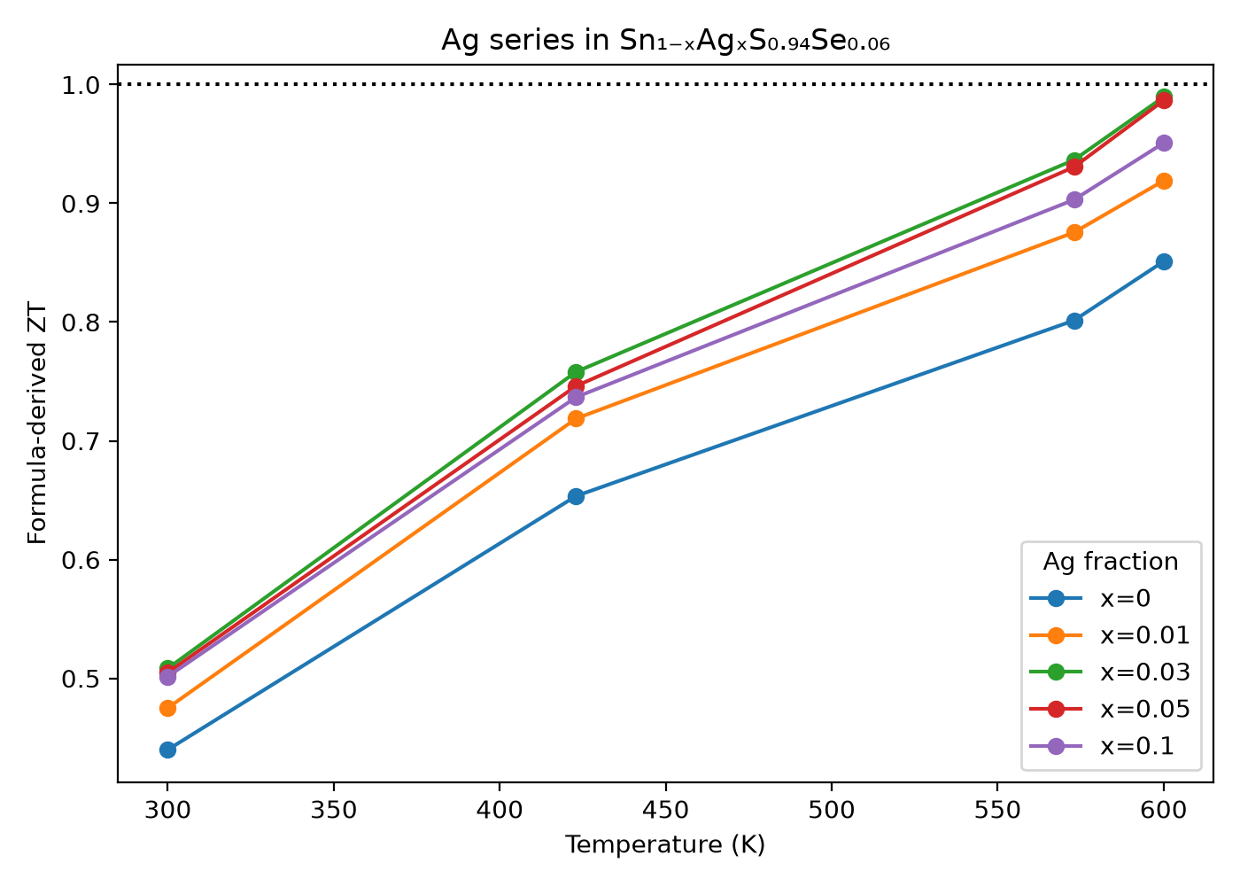
Predicted Ag-series ZT comparison.
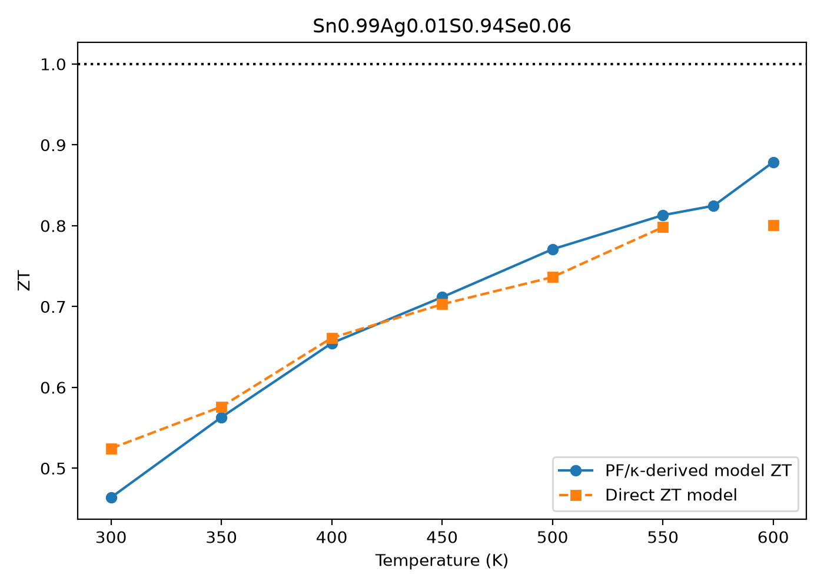
Requested Ag-doped target: PF, kappa and ZT outputs.

Advantages and limitations

Advantages
- Uses the full supplied collection and preserves source/DOI provenance.
- Uses composition-grouped validation and a held-out group check.
- Separates measured references from generated candidates.
- Includes separate PF and kappa modelling for the requested target.
- Produces reproducible tables, plots and runnable scripts.

Limitations
- No standalone pure SnSSe row was found; Co3InSnSSe is quaternary.
- Exact Ag-doped target lacks a measured PF/kappa record.
- Candidates lack DFT, phonon, elastic, molecular dynamics and experimental validation.
- ESTM and Starrydata have mixed provenance and protocols.
- Kappa is weaker than PF, increasing uncertainty in derived ZT.
- 600 K is an edge-of-range endpoint for relevant curves.
- Descriptors cannot encode all defect, band, microstructure and phonon physics.

Project files and reproducibility
The advanced workflow is in C:\Users\kraj8\OneDrive\Documents\ChatGPT\The\sn-s-se-advanced. The main script is src\run_advanced.py; the PF/kappa check is src\predict_target_pf_kappa.py; tables are in outputs\tables; plots are in outputs\plots; and source audit notes are in research_notes\SnSSe advanced ZT prediction\reference_paper_analysis.md. Run:
python src/run_advanced.py --dataset-root "C:\Users\kraj8\Dropbox\Ms thesis\Research paper\Datasets" --out-dir outputs
python src/predict_target_pf_kappa.py
The published GitHub repository for the earlier validated Sn-Na-Ag-S project is https://github.com/NischalRaj16/sn-na-ag-thermoelectric-validation. The SnSSe extension is stored in the advanced project folder with its scripts, tables and figures; remote publication status should be checked before citing it as a separate repository.

Comparison references
Reference | Comparison
Li et al., J Alloys Compd 1037 (2025) 182164, DOI 10.1016/j.jallcom.2025.182164 | ML workflow, feature selection, SHAP and DFT validation
ESTM / DOI 10.1126/science.aax5123 | Measured SnS-Se curves
Co3InSnSSe / DOI 10.1016/j.ssc.2014.09.006 | Quaternary record containing literal SnSSe
Nature Communications Sn-Na-Ag-S / DOI 10.1038/s41467-026-77691-x | Separate project comparison for formulas and grouped validation

- Reference ML paper https://doi.org/10.1016/j.jallcom.2025.182164
- Co3InSnSSe source https://doi.org/10.1016/j.ssc.2014.09.006
- ESTM-related source https://doi.org/10.1126/science.aax5123
- Sn-Na-Ag-S repository https://github.com/NischalRaj16/sn-na-ag-thermoelectric-validation

Conclusion
The collection contains measured SnS-Se compositions above zT = 1, but the feature-only models do not support a new Ag-doped SnSSe claim at or above 1 across 300-600 K. For Sn0.99Ag0.01S0.94Se0.06, the best-supported statement is a model extrapolation with PF roughly 3.74 to 1.81 mW m-1 K-2 and formula-based ZT roughly 0.48 to 0.91 from 300 to 600 K. Experimental transport and independent DFT/phonon/phase-stability checks are required before synthesis.

